  September 1st - September 28th
  Logan's Roadhouse
  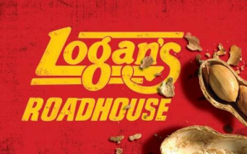
  $25 2% Bonus
  Total ScripReward 10%
  spa & wellness
  
  $25 and $100 2% Bonus
  Total ScripReward 14%
  Smart n Final
  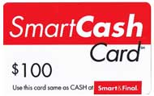
  $25, $50, $100 2% Bonus
  Total ScripReward 14%
  September 1st - September 14th
  Journey's
  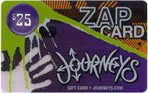
  $25 5% Bonus
  Total ScripReward 14%
  Shutterfly
  
  $25 3% Bonus
  Total ScripReward 12%
  September 1st - September 21st
  Land's End
  
  $25, $100 2%Bonus
  Total ScripReward 16%
  Organization Name:
  Contact Name:
  Contact Number:
  September 8th-28th
  Hallmark
  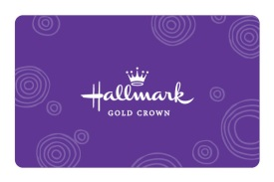
  $25 1% Bonus
  Total ScripReward 5%
  New Retailer
  Caribou Coffee
  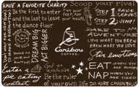
  $10 Introductory ScripReward 7%
  thru Sept. 28th.
  Beginning Sept. 29th the ScripReward
  will be 6%.
  New Denominations
  Panera $25 Bed, Bath & Beyond $100
  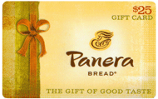
  Panera $10s and Bed, Bath & Beyond $25s will continue to be available.
  Change in Denominations
  California Pizza Kitchen, Subway
  and El Pollo Loco
  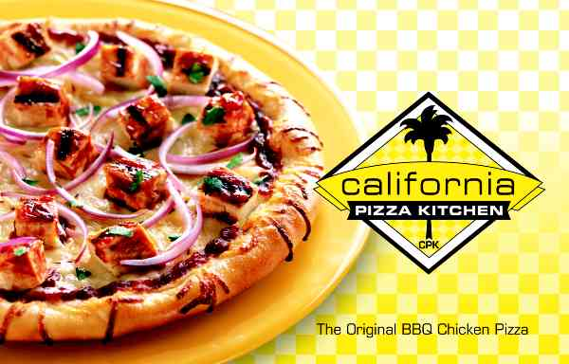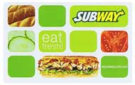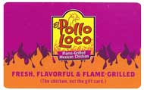
  have changed from
  $10 gift cards to a
  $25 denomination.
  Walmart Gas Rollback
  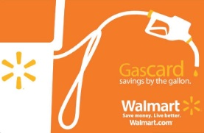
  August 31 – December 23, 2012 customers who use a Walmart gift card at a participating Murphy gas station will receive a 15 cent per gallon discount!

