UnitedScrip
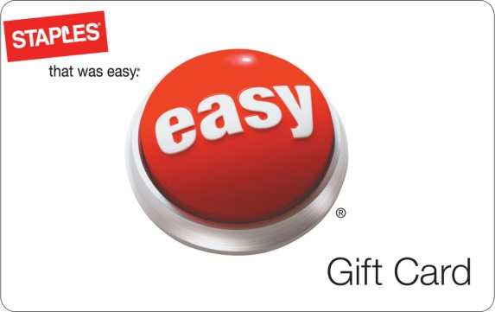
www.ScripZone.com
Making Tax Time - Bonus Time
with Staples Gift Cards

Buy a Staples® gift card and get an extra 5% for your organization.

With thousands of products to choose from, including supplies like TurboTax® and calculators, Staples gift cards are the perfect choice for tax season. Plus, if you purchase a gift card between February 20, 2012 and March 2, 2012, an additional 5% will go to your organization! Get yours today. Staples gift cards are redeemable at more than 1,600 Staples® stores nationwide.

Order online today at www.scripzone.com
Our Organization receives a 10% ScripReward from UnitedScrip with each purchase!
Contact Scrip Coordinator for details:
To order - Register at www.Scripzone.com – Join Group Id:
UnitedScrip
www.ScripZone.com
Making Tax Time - Bonus Time
with Staples Gift Cards

Buy a Staples® gift card and get an extra 5% for your organization.

With thousands of products to choose from, including supplies like TurboTax® and calculators, Staples gift cards are the perfect choice for tax season. Plus, if you purchase a gift card between February 20, 2012 and March 2, 2012, an additional 5% will go to your organization! Get yours today. Staples gift cards are redeemable at more than 1,600 Staples® stores nationwide.

Order online today at www.scripzone.com
Our Organization receives a 10% ScripReward from UnitedScrip with each purchase!
Contact Scrip Coordinator for details:
To order - Register at www.Scripzone.com – Join Group Id:

