UnitedScrip
www.ScripZone.com
Back to School purchases just became something to brag about!
$25 Gift Cards with an 8% ScripReward for your Organization!
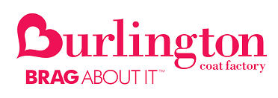
Burlington Coat Factory has something for everyone, offering current, high-quality, designer and name-brand merchandise at up to 60% off department store prices every day. Burlington is a convenient one-stop shopping experience for the entire family. Choose from a great assortment of ladies’ sportswear, menswear, family footwear, children’s clothing, furniture and accessories for baby at Baby Depot, home décor and gifts, and of course, the largest selection of coats in the nation. Now that’s something to brag about!
Order online today at www.scripzone.com
Our Organization receives a 8% ScripReward from UnitedScrip with each purchase!
Contact Scrip Coordinator for details:
To order - Register at www.Scripzone.com
------------
UnitedScrip
www.ScripZone.com
Back to School purchases just became something to brag about!
$25 Gift Cards with an 8% ScripReward for your Organization!
Burlington Coat Factory has something for everyone, offering current, high-quality, designer and name-brand merchandise at up to 60% off department store prices every day. Burlington is a convenient one-stop shopping experience for the entire family. Choose from a great assortment of ladies’ sportswear, menswear, family footwear, children’s clothing, furniture and accessories for baby at Baby Depot, home décor and gifts, and of course, the largest selection of coats in the nation. Now that’s something to brag about!
Order online today at www.scripzone.com
Our Organization receives a 8% ScripReward from UnitedScrip with each purchase!
Contact Scrip Coordinator for details:
To order - Register at www.Scripzone.com

