UnitedScrip

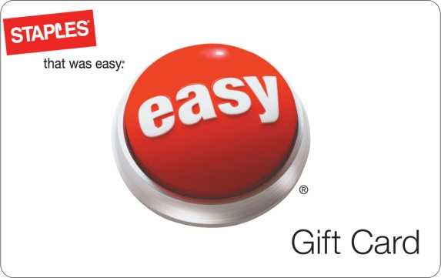
www.ScripZone.com
Staples 5% Bonus

Buy a Staples® gift card and get an extra 5% for your organization.

From your student’s favorite pencils to a new PC, Staples gift cards are the perfect way to get all the supplies on their back to school list. Plus, if you purchase a gift card between August 20, 2011 and September 2, 2011, an additional 5% will go to your organization! Get yours today. Staples gift cards are redeemable at more than 1,600 Staples® stores nationwide.
Order online today at www.scripzone.com
Our Organization receives a 10% ScripReward from UnitedScrip with each purchase!
Contact Scrip Coordinator for details:
To order - Register at www.Scripzone.com – Join Group Id:

UnitedScrip

www.ScripZone.com
Staples 5% Bonus

Buy a Staples® gift card and get an extra 5% for your organization.

From your student’s favorite pencils to a new PC, Staples gift cards are the perfect way to get all the supplies on their back to school list. Plus, if you purchase a gift card between August 20, 2011 and September 2, 2011, an additional 5% will go to your organization! Get yours today. Staples gift cards are redeemable at more than 1,600 Staples®
stores nationwide.
Order online today at www.scripzone.com
Our Organization receives a 10% ScripReward from UnitedScrip with each purchase!
Contact Scrip Coordinator for details:
To order - Register at www.Scripzone.com – Join Group Id:

