**UnitedScrip & ScripZone.com**

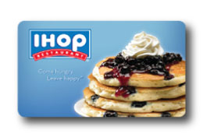

***Welcomes***   **IHOP Restaurants**

**$25 Gift Cards with an 8% ScripReward**

**for your Organization!**

**And Kids Eat FREE**

**During the month of August!**

**Everyday 4 p.m. - 10 p.m.**

For more than 50 years, IHOP has delighted guests with simple, honest food made fresh with high quality ingredients and offered at a great value. At IHOP, they are all about choice - whether you want something sweet or savory for breakfast, lunch or dinner, any time of day, IHOP offers hundreds of delicious combinations to satisfy your cravings.  IHOP also provides ways to enjoy their food that fits with your nutrition goals. With IHOP gift cards, you will enjoy an extensive menu of mouthwatering breakfast, lunch and dinner favorites at over 1,500 restaurants conveniently located in all 50 states.

IHOP gift cards also have an extensive menu of hassle-free features that you’ll love - no fees, no expiration.

 Scrip Makes it Easy!  YOU Make it Count!

[Store locator](http://ihoplocator.com/)

Check out the ["SIMPLE & FIT"](http://www.ihop.com/index.php?option=com_content&task=view&id=227&Itemid=2) menu of under 600 calorie items or use our tips on how to enjoy lower calorie versions of your favorite IHOP classics by making a few changes when you order.

IHOP gives you the freedom to choose

no matter what you're looking for.