  HOLIDAY SPECIALS NEW RETAILERS INCREASED DISCOUNTS    1% Bonus  Until 11/30/10  $25  Now 5% |   2% Bonus  Until 12/30  $25 or $100  Now 7% |   5% Bonus  11/08 – 12/6  10 - $25  Now 18% |   1% Bonus  Until 12/30  $25 or $100  Now 3% |   5% Bonus  11/15 – 12/10/10  $25  Now 14%
  3% Bonus  11/15 – 12/10/10  $25  Now 11% | 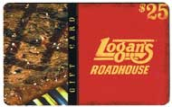  2% Bonus  11/15 – 12/30  $25  Now 10% |   1.5% Bonus  11/15 – 12/30  $10 or $25  Now 11.5% |   New Increased  Discount  $15 and $25  Now 5% | 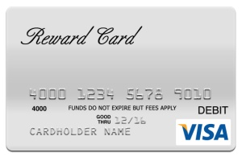  Visa Reward Card*  2%  $25 and $50  *Restrictions Apply

