  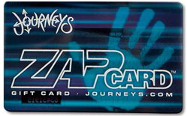  3% Bonus  Journeys, Shi,  Journey Kidz  $25  Now 12%  Until 12/30 |   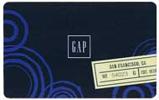  3% Bonus  Gap, Old Navy, Piperlime.com, Athleta.com  $25 Now 12%  Until 12/30 | 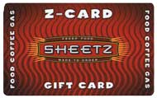  1% Bonus  Sheetz  10 - $25  Now 18%  Until 12/30 |   1% Bonus  Home Depot  $25 - $5000  Now 3%  Until 12/10 |   5% Bonus  Shutterfly  $25  Now 14%  Until 12/30
  3% Bonus  Jiffy Lube  $25  Now 11%  Until 12/10 | 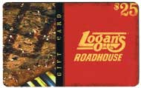  2% Bonus  Logan’s Roadhouse  $25  Now 10%  Until 12/30 | 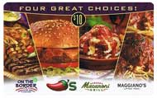  1.5% Bonus  Chili’s, On The Border, Macaroni Grill, Maggiano’s  $10 or $25  Now 11.5%  Until 12/30 |   2% Bonus  The Children’s Place  $25  Now 14%  Until 12/30  New Increased  Discount  $15 and $25  Now 5% | 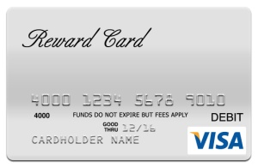  Visa Reward Card*  2%  $25 and $50  *Restrictions Apply
 | 3% Bonus  Gap, Old Navy, Piperlime.com, Athleta.com  $25 Now 12%  Until 12/30 | 1% Bonus  Sheetz  10 - $25  Now 18%  Until 12/30 | 1% Bonus  Home Depot  $25 - $5000  Now 3%  Until 12/10 | 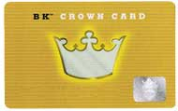  1% Bonus  Burger King  $10  Now 5%  Until 12/17 |  | 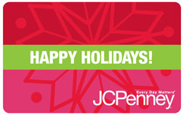  2% Bonus  JCPenney  $25 or $100  Now 7%  Until 12/30 |   5% Bonus  Bath&Body Works  $10 - $25  Now 18%  Until 12/6 |   1% Bonus  Best Buy  $25 or $100  Now 3%  Until 12/30 | 5% Bonus  Shutterfly  $25  Now 14%  Until 12/30
   | 3% Bonus  Gap, Old Navy, Piperlime.com, Athleta.com  $25 Now 12%  Until 12/30  Until 12/10 | 1% Bonus  Sheetz  10 - $25  Now 18%  Until 12/30 | 1% Bonus  Home Depot  $25 - $5000  Now 3%  Until 12/10 | 1% Bonus  Burger King  $10  Now 5%  Until 12/17
    3% Bonus  Rocky Moutain Chocolate Factory  $25  Now 12%  Until 12/30 | 2% Bonus  Until 12/30  $25 or $100  Now 7% | 5% Bonus  11/08 – 12/6  10 - $25  Now 18% | 1% Bonus  Until 12/30  $25 or $100  Now 3% | 5% Bonus  11/15 – 12/10/10  $25  Now 14%
    3% Bonus  11/15 – 12/10/10  $25  Now 11% | 2% Bonus  11/15 – 12/30  $25  Now 10% | .5% Bonus  11/15 – 12/30  $10 or $25  Now 11.5% | New Increased  Discount  $15 and $25  Now 5% | Visa Reward Card*  2%  $25 and $50  *Restrictions Apply
  1% Bonus  Burger King  $10  Now 5%  Until 12/17  3% Bonus  11/15 – 12/10/10  $25  Now 11% | nus  11/15 – 12/30  $25  Now 10% | 1.5% Bonus  11/15 – 12/30  $10 or $25  Now 11.5% | New Increased  Discount  $15 and $25  Now 5% | isa Reward Card*  2%  $25 and $50  *Restrictions Apply
  4% Bonus  Sports Authority  $25  Now 12%  Until 12/30 | 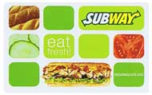  4% Bonus  Sports Authority  $25  Now 12%  Until 12/30 |   2% Bonus  American Girl  $25  Now 10%  Until 12/30 |   NEW Retailer  BedandBreadfast.com  $25  Now 12% |   NEW Retailer  Ben and Jerry’s  $25  8% |  | 2% Bonus  Logan’s Roadhouse  $25  Now 10%  Until 12/30 | 1.5% Bonus  Chili’s, On The Border, Macaroni Grill, Maggiano’s  $10 or $25  Now 11.5%  Until 12/30 |   New Increased  Discount  $15 and $25  Now 5% | Visa Reward Card*  2%  $25 and $50  *Restrictions Apply

