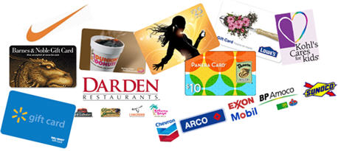

What Is Scrip?
Scrip is a term that means “substitute money”. When you purchase scrip, you’re purchasing negotiable gift certificates and prepaid cards that are used just like cash. You can use scrip to purchase everyday expenses like food, clothing, and other essentials, and with every purchase, you earn revenue for our organization.

How scrip generates revenue for you
UnitedScrip acts on behalf of churches, schools and other non-profit organizations to purchase large amounts of scrip from grocery stores, department stores, and other retailers. Because the scrip is purchased with cash up front, the participating retailers offer a substantial discount. Our organization buys the scrip UnitedScrip at a discount, and re-sells the certificates to families like yours for full face value. The discount - from two to fifteen percent or more – is our organization’s revenue.

Scrip is "making every purchase profitable!”
Scrip is a popular fundraiser because families do not have to sell anything. Organization members produce revenue by making regular household purchases they would make anyway. Groceries, clothing, toys, gifts, even gasoline can be purchased with scrip.

Find Out More
Ask your scrip coordinator listed below for the latest participating retailer list. Then put your shopping dollars to work for our organization!

In partnership with UnitedScrip
Contact
Submit orders to:
Schedule: ( Example- Orders due Tuesdays
Pick up Fridays SHS Band Room 7p.m.)



Making Every Purchase Profitable for Your Organization
www.unitedscrip.com

What Is Scrip?
Scrip is a term that means “substitute money”. When you purchase scrip, you’re purchasing negotiable gift certificates and prepaid cards that are used just like cash. You can use scrip to purchase everyday expenses like food, clothing, and other essentials, and with every purchase, you earn revenue for our organization.

How scrip generates revenue for you
UnitedScrip acts on behalf of churches, schools and other non-profit organizations to purchase large amounts of scrip from grocery stores, department stores, and other retailers. Because the scrip is purchased with cash up front, the participating retailers offer a substantial discount. Our organization buys the scrip UnitedScrip at a discount, and re-sells the certificates to families like yours for full face value. The discount - from two to fifteen percent or more – is our organization’s revenue.

Scrip is " making every purchase profitable!”
Scrip is a popular fundraiser because families do not have to sell anything. Organization members produce revenue by making regular household purchases they would make anyway. Groceries, clothing, toys, gifts, even gasoline can be purchased with scrip.

Find Out More
Ask your scrip coordinator listed below for the latest participating retailer list. Then put your shopping dollars to work for our organization!

In partnership with UnitedScrip
Contact
Submit orders to:
Schedule: ( Example- Orders due Tuesdays
Pick up Fridays SHS Band Room 7p.m.)

Making Every Purchase Profitable for Your Organization
www.unitedscrip.com

