  Bath & Body Works  5% Bonus ScripReward  $10 Off Coupon    Holiday ScripReward  Total 18%  Offer Expires 12/24  Coupons valid in stores only until December 31 | Logan’s  $5 Logan’s Bucks  with $25 gift card purchase  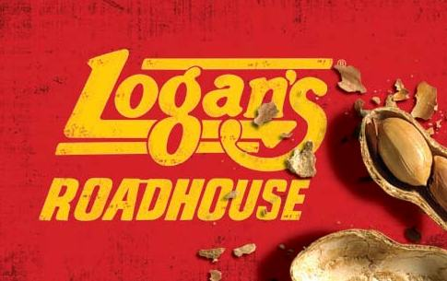  ScripReward 8%  Offer expires 12/24  Logan’s Bucks expire 2/10/12  Not valid in NC, SC, Augusta GA) | Jiffylube  $5 Off Coupon  3% ScripReward Bonus    Holiday ScripReward Total 12%  Offer Expires 12/31 | Smart & Final  2% Bonus ScripReward    Holiday ScripReward Total 5%  Offer Expires 12/31 | Men’s Wearhouse  50% Bonus Coupon  with $25 card purchase    ScripReward 7%  Offer Expires 12/24  Coupon applies to single item  Until 12/31
Hallmark  1% Bonus ScripReward    Holiday ScripReward Total 5%  Offer Expires 12/24 | Steak’n Shake  Free $5 Certificate  with $20 in Gift Cards    ScripReward 8%  Offer Expires 12/31  (Coupons redeemable  through 2/28/12) | Rock Bottom  5% Bonus ScripReward  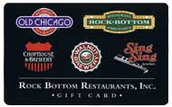  Holiday ScripReward Total 11%  Offer Expires 12/24  Holiday ScripReward Total 5%  Nov. 5 – Dec. 31 (Total ScripReward 11%) | Shutterfly  5% Bonus ScripReward    Holiday ScripReward Total 14%  Offer Expires 12/31 | Rocky Mt. Chocolate Factory  2% Bonus ScripReward    Holiday ScripReward Total 14%  Offer Expires 12/24
Journeys  5% Bonus ScripReward  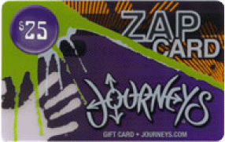  Holiday ScripReward  Total 14%  Offer Expires 12/31 | Sears  3% Bonus ScripReward    Holiday ScripReward  Total 7%  Nov. 12 – Dec. 02 | Brunswick  $5 Bonus Certificate with $25 gift card purchase    ScripReward Total 12%  Offer Expires 12/31 | California Pizza Kitchen  2% Bonus ScripReward    Holiday ScripReward Total 6%  Nov. 12 – Dec. 23 | Sheetz  1% Bonus ScripRewards  Effective 11/12/11 thru 12/24/11  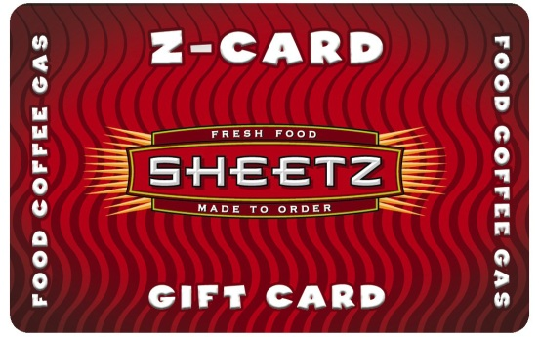  Holiday ScripReward Total 4%  Offer Expires 12/24
Gift Card Holders  $.50 each  Varies designs available.  Call or email for additional information.  864.886.9701  cmrampey@unitedscrip.com | Gordmans  1% Bonus ScripReward    Holiday ScripReward Total 8%  Offer Expires 12/11 | T.G.I.FRIDAY’S  $5 Bonus Bites  with $25 gift card purchase    ScripReward Total 9%  Offer Expires 12/24 or while supplies last  Bonus Bites Valid  1/2/12 -3/31/12 | Orders Due:  Contact:  Phone:  Email:

