To submit your One Time Fundraiser orders:

- Choose “Go to Place an Order.”
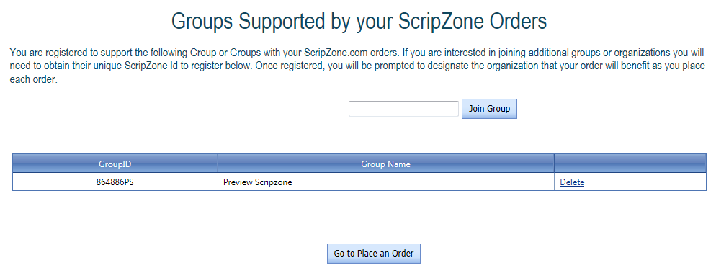

- Select “Set Information for this Order”

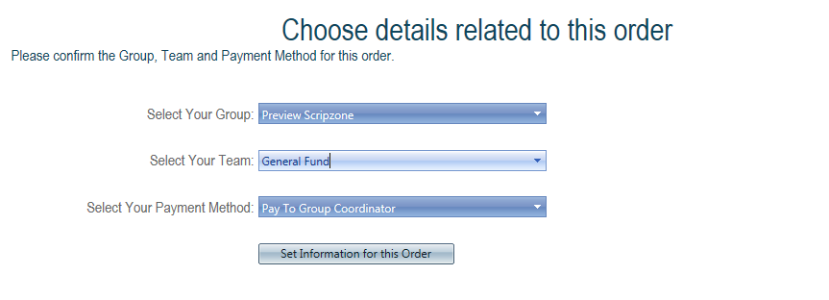
- Click on Scrip Suggest and then type in the certificates and quantities needed for one customer.
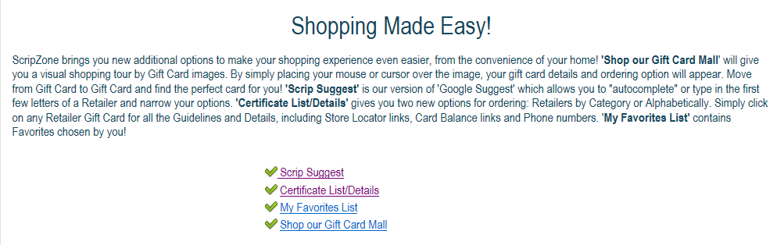
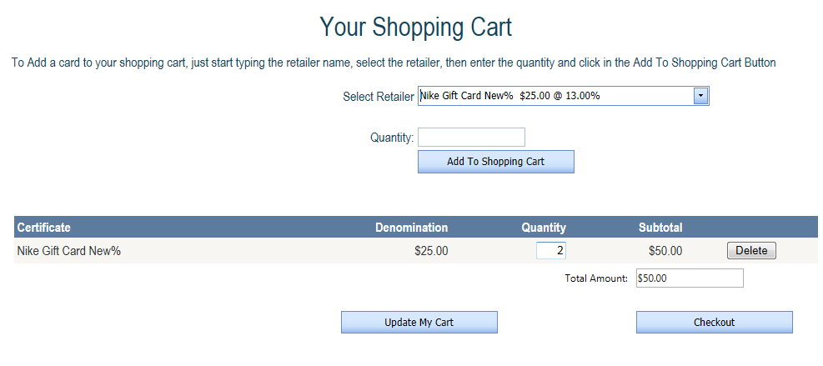
- Click on Checkout.

- In the Comments box, type Purchased by and add customer’s name.

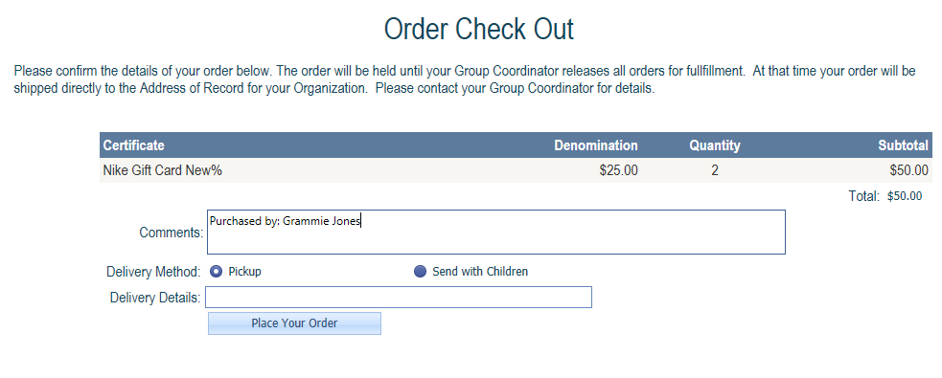
Click on “Place Your Order.”
- When you see this screen, the order has been submitted. To add another customer order, Click on “Start a New Order.”
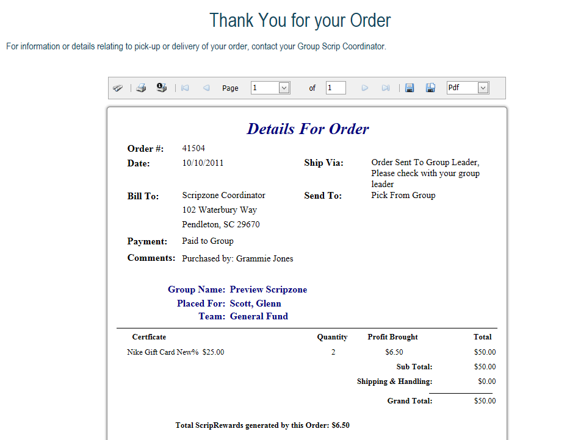

You will be directed to the following screen. Follow this process to add each order.
