A Great Deal for You from Black Angus
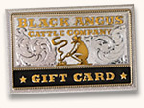

Enjoying a ‘Campfire Feast for Two’ …Delicious!

Having a night out together
…as rare as the Steaks!
Saving $10…as sweet as dessert!
Making a Difference for (insert your group name)…Excellent!

Making fundraising easy…Priceless!

Order $50 in Black Angus Steakhouse

Gift Cards
and receive with your order
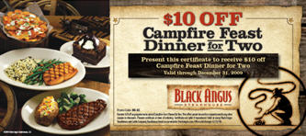

Fundraising….That was Easy! www.unitedscrip.com
A Great Deal for You from Black Angus

Enjoying a ‘Campfire Feast for Two’ …Delicious!

Having a night out together
…as rare as the Steaks!
Saving $10…as sweet as dessert!
Making a Difference for (insert your group name)…Excellent!

Making fundraising easy…Priceless!

Order $50 in Black Angus Steakhouse

Gift Cards
and receive with your order

Fundraising….That was Easy! www.unitedscrip.com

