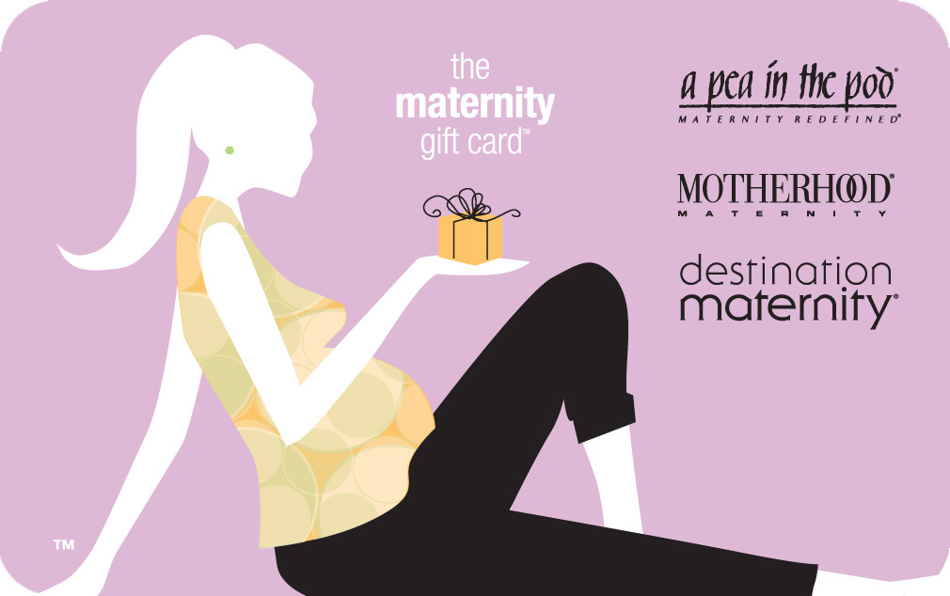

The Maternity Gift Card
Id Code 957 $25 Gift Card 8%

Celebrate pregnancy, one of the most special times in a woman's life, with The Maternity Gift Card™. Destination Maternity brands offer thousands of ways for expectant women to be themselves, from sexy and sporty to poised and professional. Shopping is easy with over 650 store locations across the US. The Maternity Gift Card™ can be redeemed at all Motherhood® Maternity, A Pea In The Pod®, Destination Maternity®, and Edamame® spa locations, as well as online at Motherhood.com, Apeainthepod.com, Destinationmaternity.com, or by phone at 1-800-4-MOM2BE.

To find a location near you, please visit www.destinationmaternity.com.

Here is a highlight of Destination Maternity’s 3 brands as well as the Edamame Spa where your gift card is also redeemable at.



Motherhood® Maternity offers a complete selection of the latest fashions at amazing low prices. From sexy and sophisticated to bold and beautiful, Motherhood® Maternity has everything the mom-to-be could ever want or need at the lowest prices around.

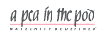

A Pea in the Pod®: From sophisticated luxury to fun casual looks,
A Pea in the Pod® offers the mom-to-be exceptional contemporary pieces that reflect her uncompromising sense of style. Free-spirited and original, classic and modern… A Pea in the Pod® (formerly Mimi Maternity®) is maternity redefined.



Destination Maternity® is the ultimate maternity superstore. The huge selection of fashion offers all three brands, plus skincare, fitness, and nutritional products to pamper the pregnant woman - even classes to condition the mind and body.



Edamame®, pronounced ed-duh-mah-may, is NOT your mother's spa. Here, mothers-to-be lose themselves in a luxurious Zen-like retreat. Tranquil ocean sounds and soothing teas are just the start of this pampering experience, including a complete menu of spa treatments specially designed to rejuvenate the expectant mom's mind, body, and spirit.

