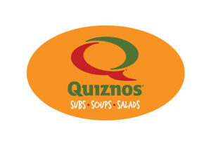
Quiznos is Back! Just in time to keep up with your schedule, pack for lunches, or grab a bite on the way to or from games, practice or to end a busy day! Quizno’s Gift Cards will not only make you say MMMMM…but also Make a Difference for our Organization!
Scrip Makes it Easy! You Makes it Count! Id Code 44510 $10 Gift Cards @ 10.5% Profit for your Organization!

---------------

Quiznos is Back! Just in time to keep up with your schedule, pack for lunches, or grab a bite on the way to or from games, practice or to end a busy day! Quizno’s Gift Cards will not only make you say MMMMM…but also Make a Difference for our Organization!
Scrip Makes it Easy! You Makes it Count! Id Code 44510 $10 Gift Cards @ 10.5% Profit for your Organization!

---------------
Quiznos is Back! Just in time to keep up with your schedule, pack for lunches, or grab a bite on the way to or from games, practice or to end a busy day! Quizno’s Gift Cards will not only make you say MMMMM…but also Make a Difference for our Organization!
Scrip Makes it Easy! You Makes it Count! Id Code 44510 $10 Gift Cards @ 10.5% Profit for your Organization!

